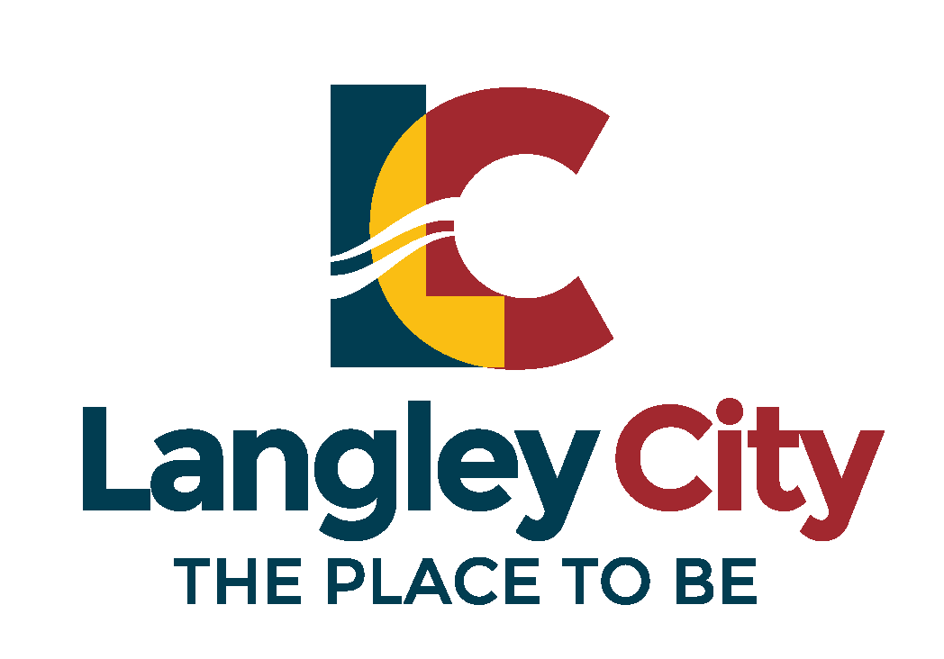 | The City of Langley
 | 20399 Douglas Crescent
 | Langley, BC V3A 4B3
Attention: Director of Corporate Services
Phone: 604-514-2806 Fax: 604-530-4371
COMMUNITY GRANT APPLICATION FORM
IMPORTANT: The deadline for the 2021 Community Grant Applications is
June 30, 2021.

IDENTIFICATION:
Name of Organization:

Contact Person: | Home Phone: | Business Phone:
Mailing Address:

Email Address:

ORGANIZATION INFORMATION:
Organization Goals, Objectives & Activities:

Service provided to the Community:

A brief profile and history of the organization and its accomplishments.
(You may include a one page attachment with this information)

GRANT REQUEST:
Amount of request  $ | Proposed allocation of funding – Detailed budget for Project or Capital Expenditure (You may include a one page attachment with this information)
In-kind services (support) from the City (please include description)
$

Purpose of the Grant (You may include a one page attachment with this information)

Benefits to Community resulting from grant or City goals and objectives that will be met, if the grant is approved  (You may include a one page attachment with this information) | Current financial support or sponsorship from others in the community; (You may include a one page attachment with this information)

CHECKLIST OF ADDITIONAL REQUIRED DOCUMENTS:

⁯ Most recent set of annual financial statements
⁯ Minutes of most recent AGM
⁯ List of Executive Members (positions held, address and contact numbers)
⁯ Registered society status (if applicable)

For newly formed groups, a current budget will be sufficient in place of providing financial statements.

____________________________________ ________________________________
Date Signature

